**Create ETO and MyInbox Testing Guide (HPS ONLY)**

**Using The User ID for Inside Sales** : TESTUSER20

**Testing with sales Order No :**15186599

Relevant users will have access to the following two tiles namely

* Create ETO (Inside Sales)
* My Inbox (The different Individuals/groups involved in processing the orders ex App Engg.etc)

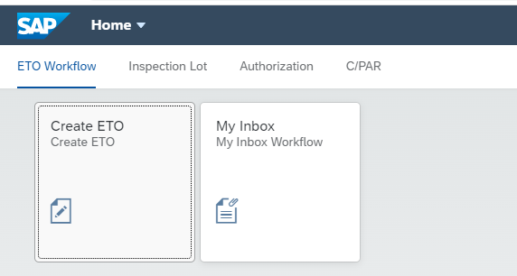

**Create ETO Screen**

Clicking on the Create ETO Tile will bring the user to the screen below

User will input the sales order number and press GO button.

If an invalid sales order number is entered, there will be an error message

Request status will be defaulted to “New”

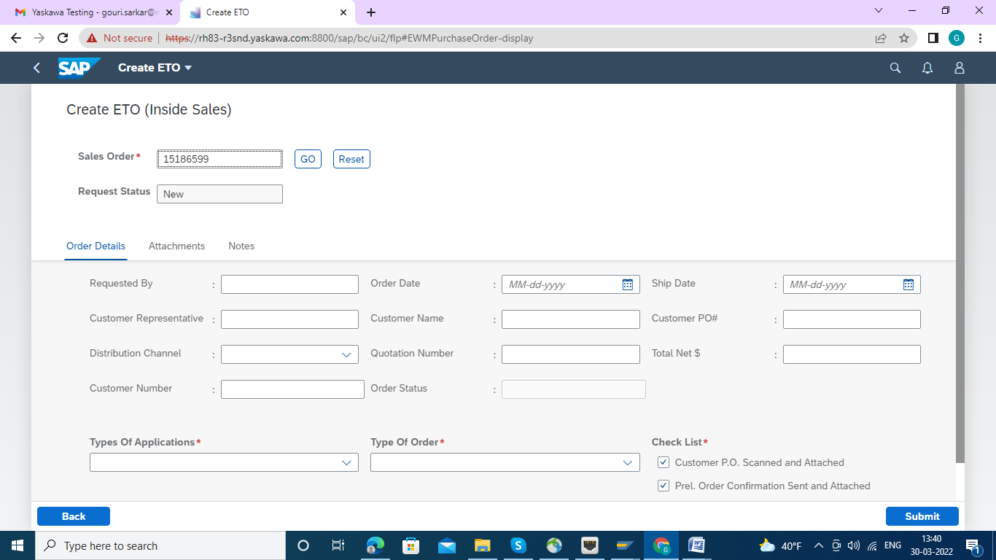

On Successful entry of a Sales Order, the details of the SO will be displayed in the screen with the following tabs

* Order Details
* Attachments
* Notes

**Order Details Tab:** User can edit the fields as required. For ex. to change the Ship Date, Distribution channel etc

Note: Please insert "Quotation Number" : while inserting Quotation No. no parenthesis is applicable here.

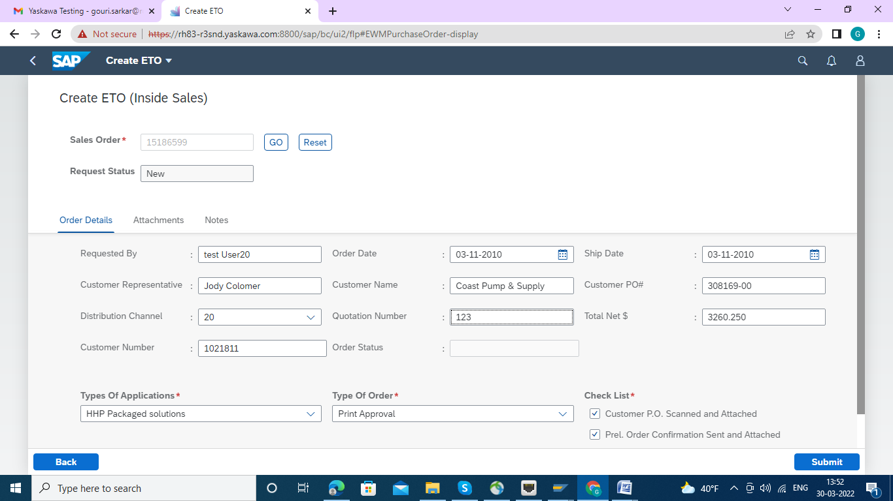

Then Click on:

**Attachment Tab :**All the documents that are part of the initial Sales order will be displayed

User has option to add the new attachment by clicking on the “Add Attachment” button.

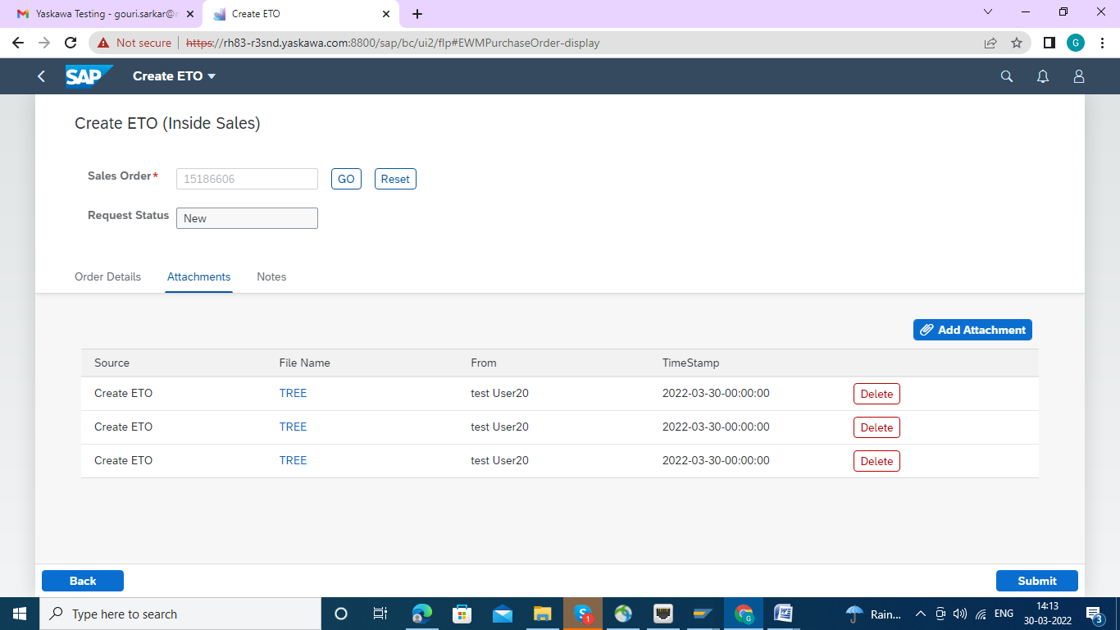

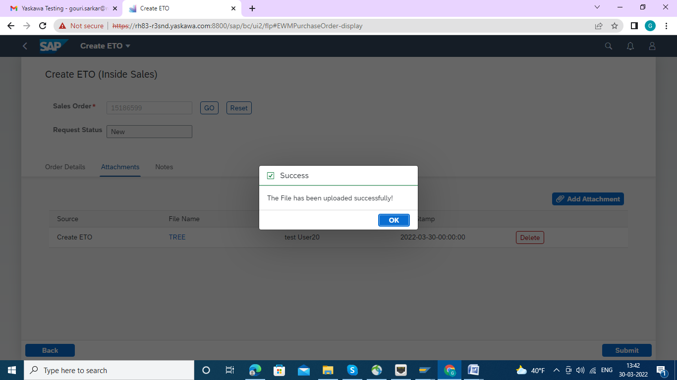

**Notes Tab:** User can add additional notes in this tab in the field provided for notes

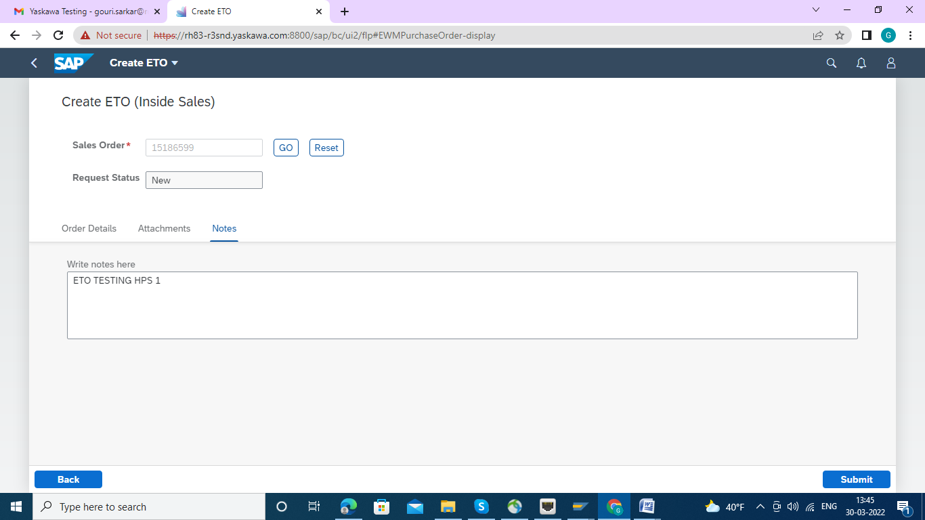

**Create ETO (WorkFlow Trigger)**

In the order details tab User can select the options in the following fields (Drop down menu highlighted)

- Type of Application

- Type of Order

Once Submit button is pressed Email notification will be sent to the respective Engineering department based on combinations and one general notification will be created in the backend.

Selecting Here :Types of Application as "HHP Package Solutions" and Type of Order as "Print Approval" as this ETO is making for HPS.

Marked the Check List as applicable.



Now Press the "Submit" Button and the Message has come that Notification No. has generated and that no. has been sent to the APP Engineer HPS Group via Email.

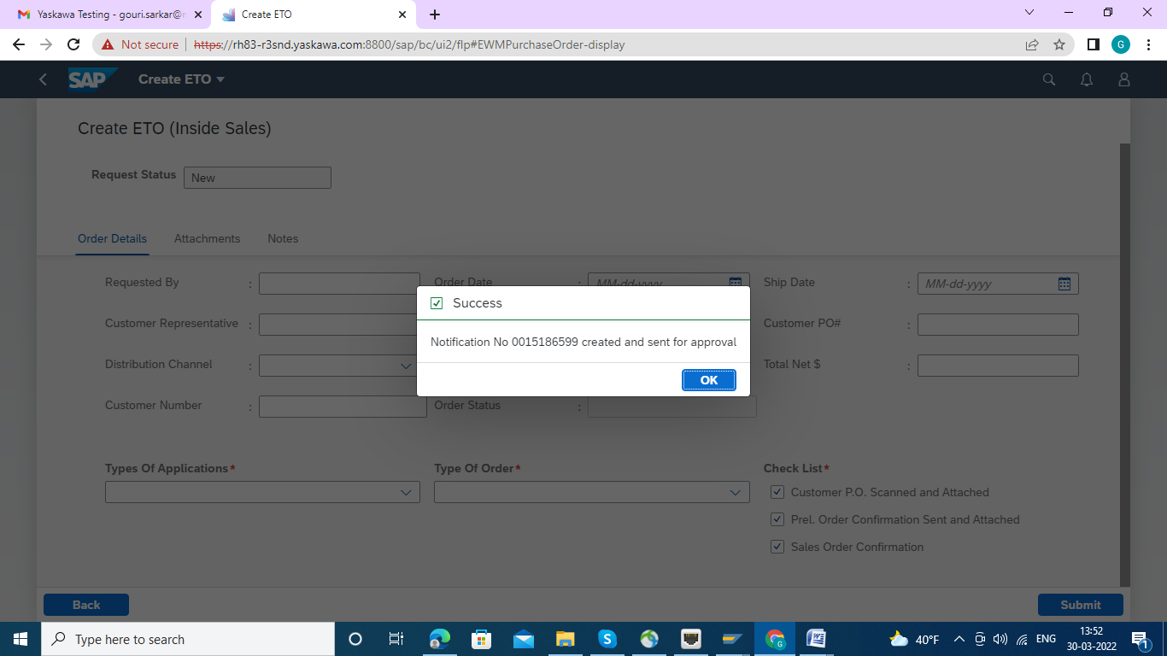

**MyInbox Testing Guide**

This Test has been conducted as "APP Engineer HPS" , using the User ID: TESTUSER22 , defined Sales Order 15186599, which was created earlier through ETO by Inside Sales.

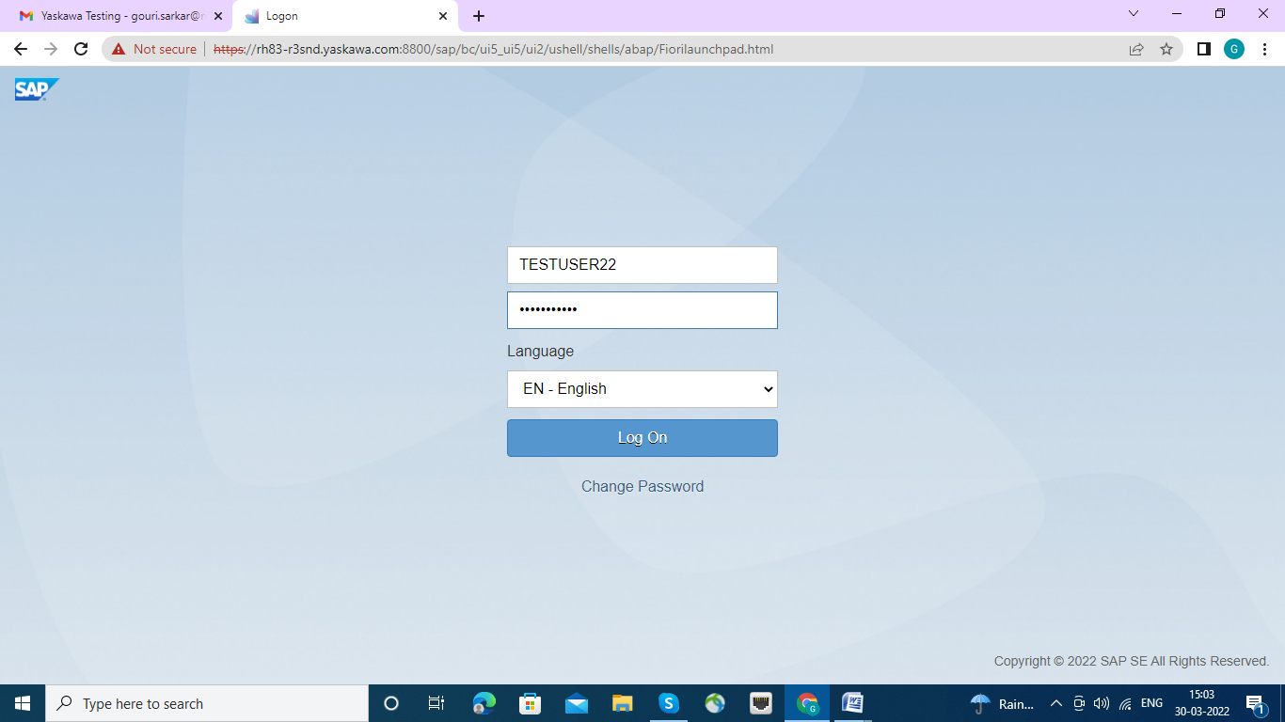

After login ,the below screen appeared.

Clicking on the My Inbox Tile will navigate to the “My Inbox screen”

All the Sales orders which are triggered from the Create ETO screen to a particular person will be visible in this Screen

User can also search and filter for SO’s assigned to other users or groups

For ex : SO1,SO2 are triggered to **User A** , when **User A** opens the my Inbox with his/her login credentials then SO1 and SO2 will be visible to him/her .

Along with that there are also different filter options where user can filter the values and see other Sales orders based on the filter value.

The red highlighted box will be for filter/search values. The SO details will be shown below the filter box with distinct Sales Order details.

This will show list of distinct Sales order number with header details.

User can select the SO/SOs and has option to reassign or accept the SO for further processing

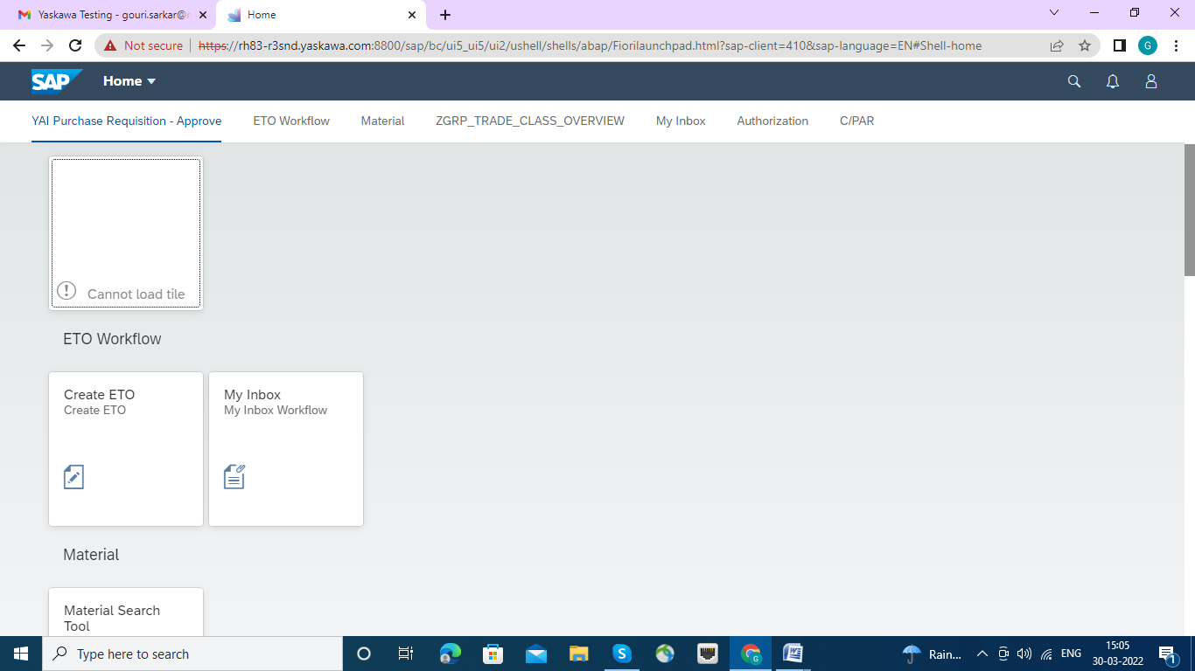

Double click on "My Inbox" the "ETO-MyInbox" page has been opened up

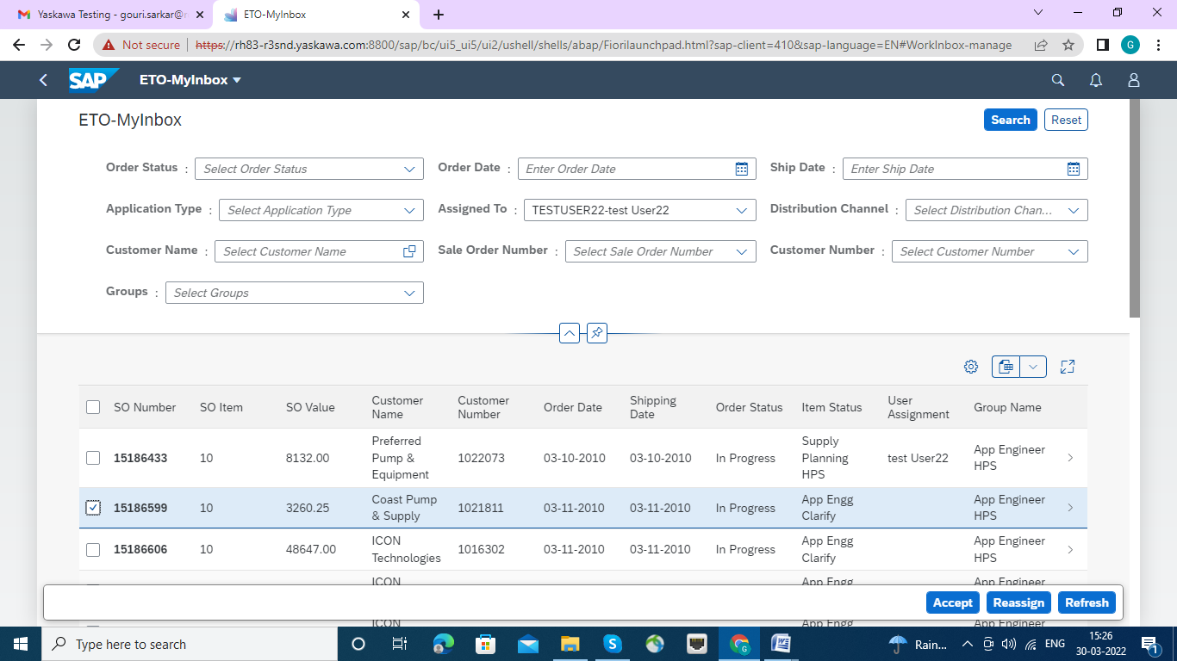

**Reassign**

If user chooses to reassign one or more SO to a particular group or individual, the selected Sales Order/Orders will be updated with the assigned person/Group name and intimation mail will be sent to inform them that the Sales Order/Orders are assigned to them.

Screen shot shows when the reassign button is pressed the option to select Individuals/Groups. If a user is selected then the groups to which he available will be shown in the drop down. Or else a particular group can be assigned without assigning an individual

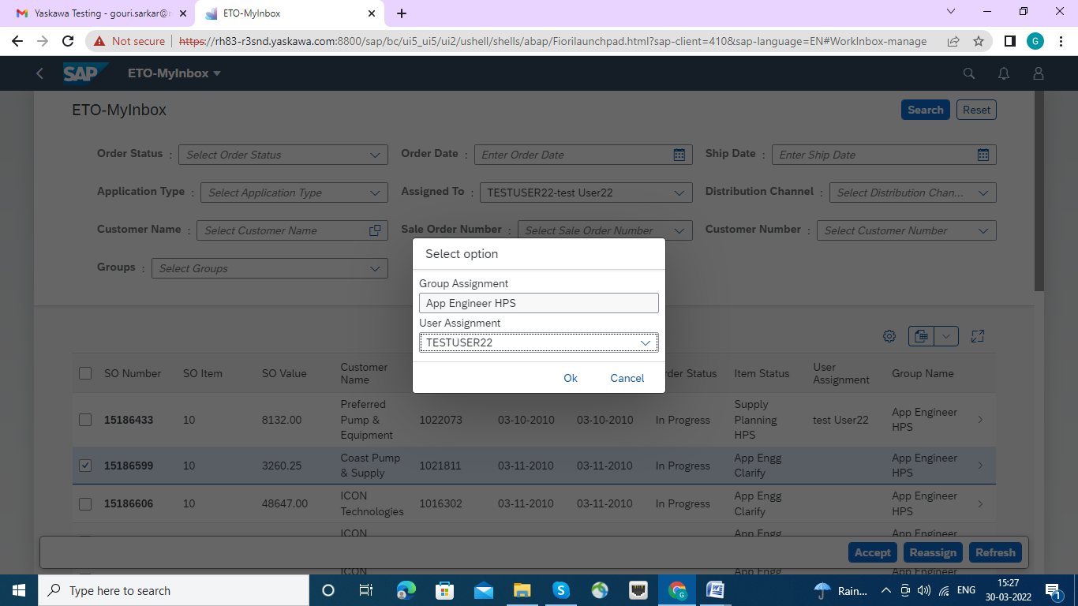

After assign user Assignment and click on OK button , Message displayed success .

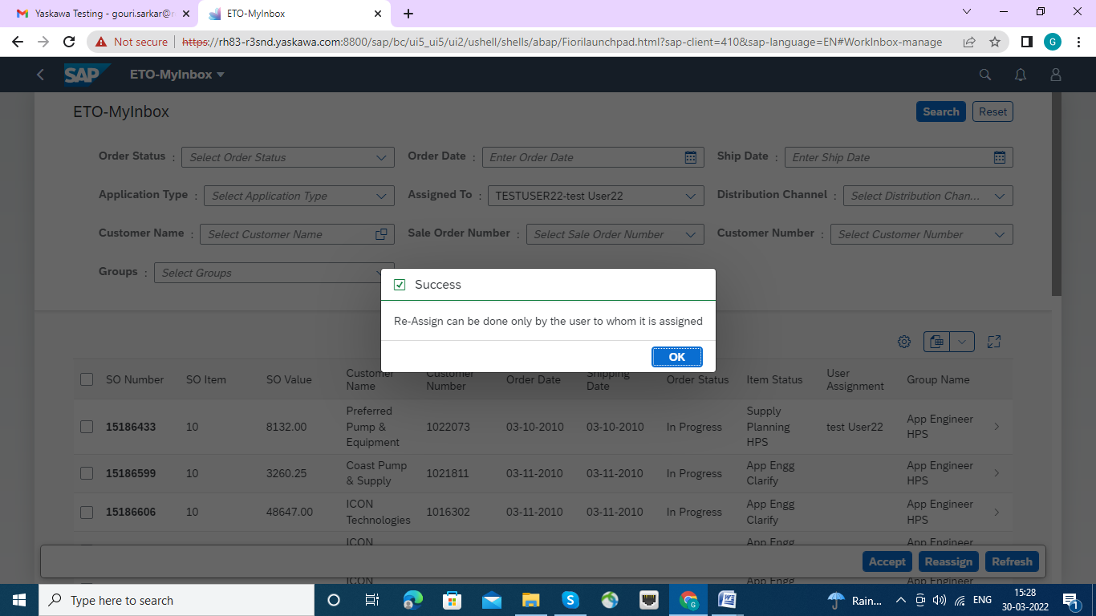

Now, Sales order having with one line Item : 15186599 has been accepted .

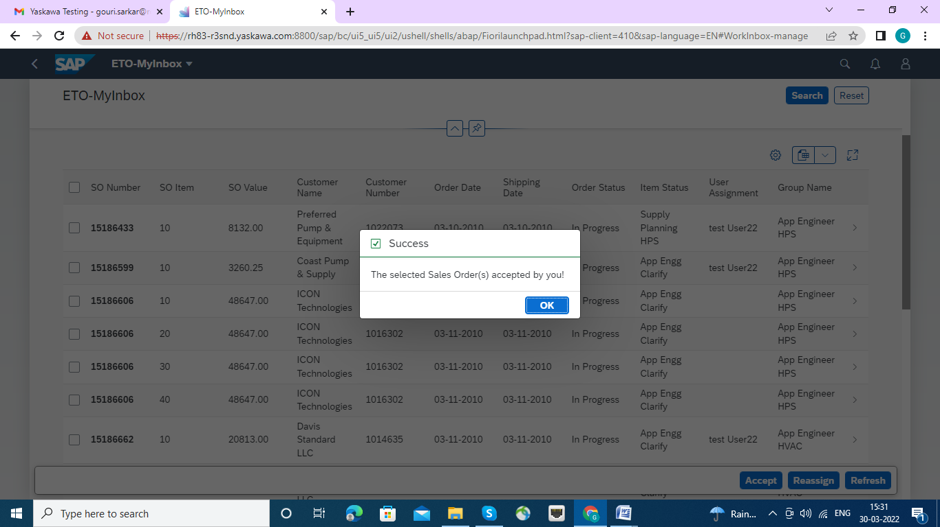

Please click on Accept Button.

**SO Details Screen for HPS**

**In Application Engineering Section page**

A user assigned to an SO and accepted it will further process the order as below.

As a next step user will double click on the SO to navigate to the detail screen wherein all the details of the selected SO will be displayed in following tabs

* Header Details
* Order Details
* Attachments
* Notes
* Log Details

**Header Details Tab**

All the Header details of the particular SO will be displayed. User can add additional information

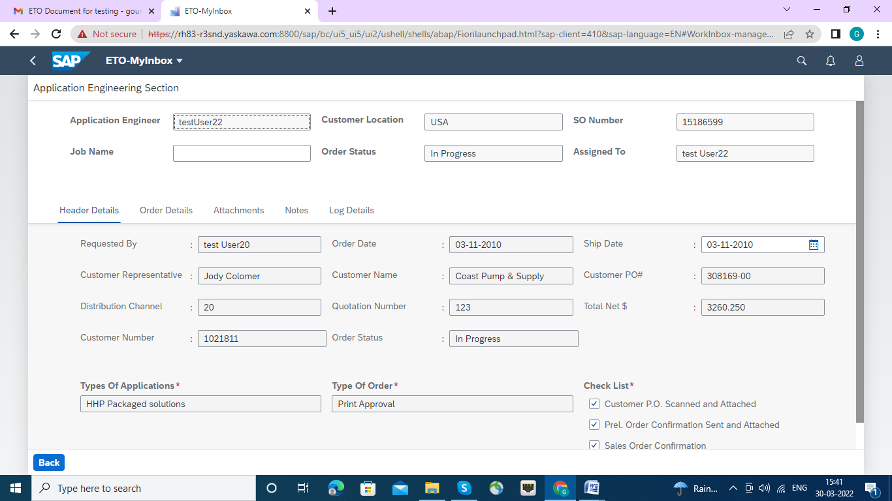

The Job Name filed is being populated here.

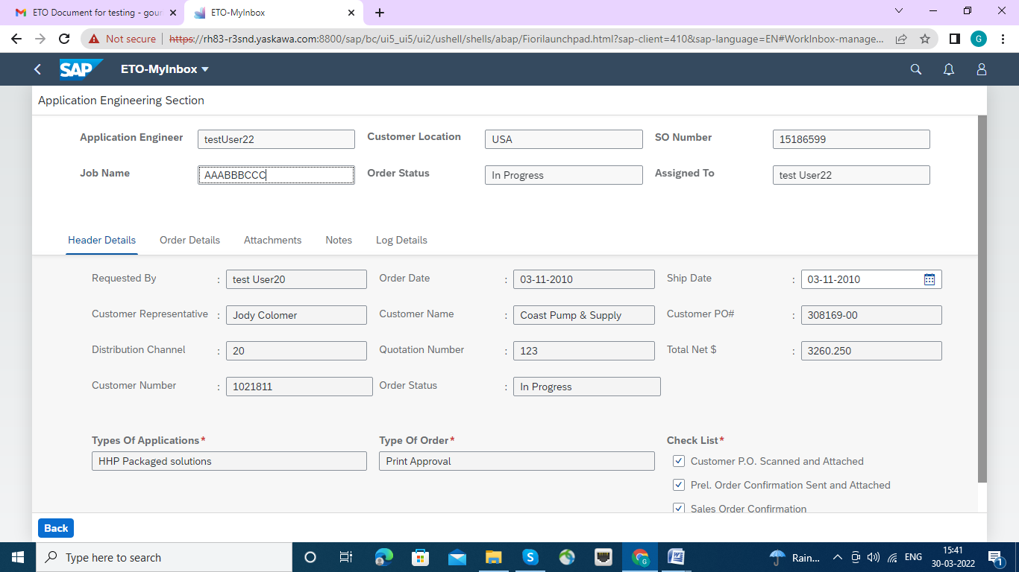

**Order Details Tab**

In the below screen all the line-item details of the selected SO will be displayed

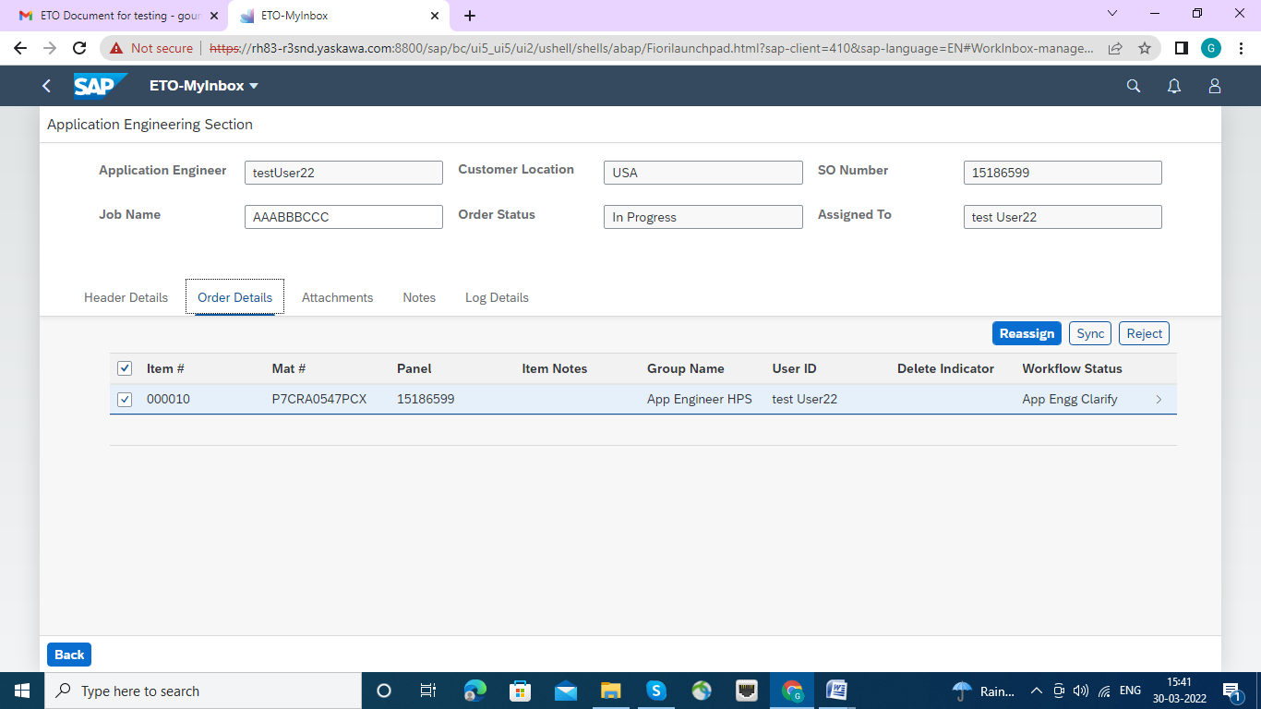

**Attachment Tab**

Attachment tab will show all the attachments for a SO (original from sales order, any new added attachments while creating an ETO )

New attachment addition is also possible.

Attachments will be displayed along with history log.

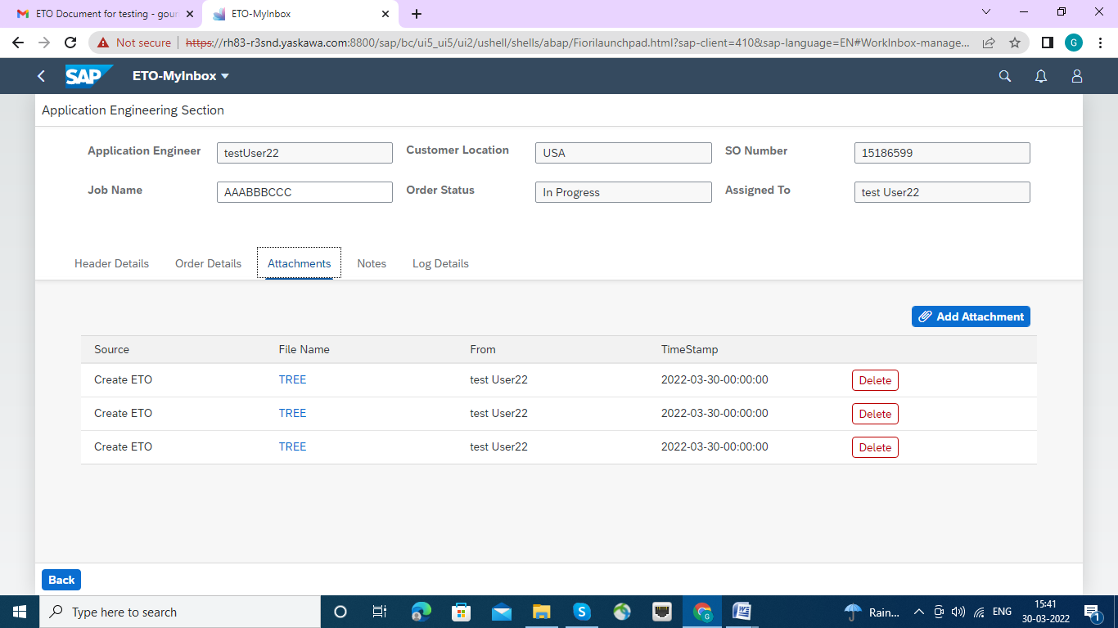

**Notes Tab**

In notes tab will display any added notes at time of creation and new additional notes can be added.

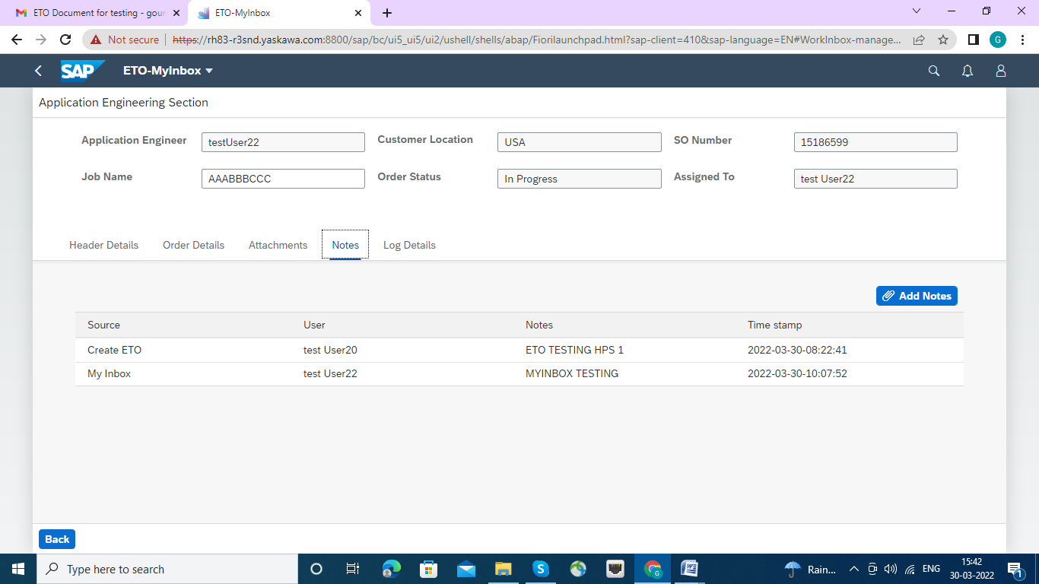

**Log Details Tab**

In log details tab, all the history log for that selected SO will be displayed

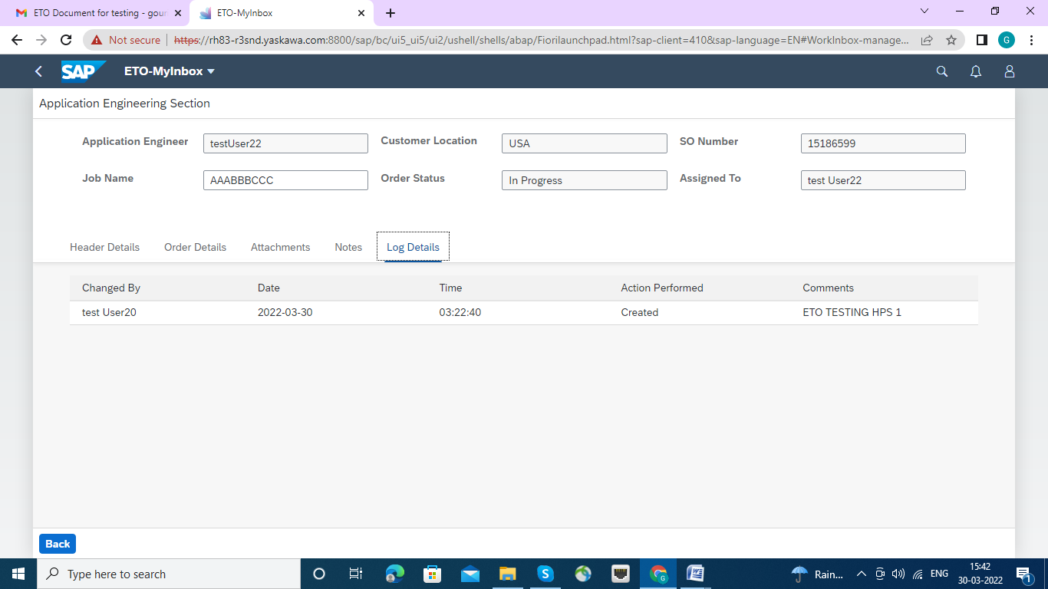

**Now Navigation to detail screen line item wise.**

User will double click on the individual line item and enter the detail screen and double click on Material number .



That Double Click on Material Number lead to us in "Item Details"page and Tabs for HPS Types Order :

There are Six Types of HPS Orders and sequential Workflows are assign with.

|  |  |
| --- | --- |
| HPS Type Orders | Work Flows |
| 1. Product Type | Engineering Schedular |
| 2. Material Details | Supply Planning HPS |
| 3. Pre -Order Items | Engineering Upload |
| 4. App Engineering - HPS | Order Engineering HPS |
| 5. Order Engineering | Engineering Schedular |
| 6. PA/Submittal | Marcom HPS |

Each Time after Submission the "Submit Tab" page will back the user to ETO-MYInbox , so , every time User will come from **ETO-MYInbox** > **Application Engineering Section> Item Details .**

HPS Types Orders:

1. Product Type

2. Material Details

3. Pre -Order Items

4. App Engineering - HPS

5. Order Engineering

6. PA/Submittal

Click on Product Type : where Strategy Group may be maintained by selecting the appropriate strategy from Drop down list , as per next screen.

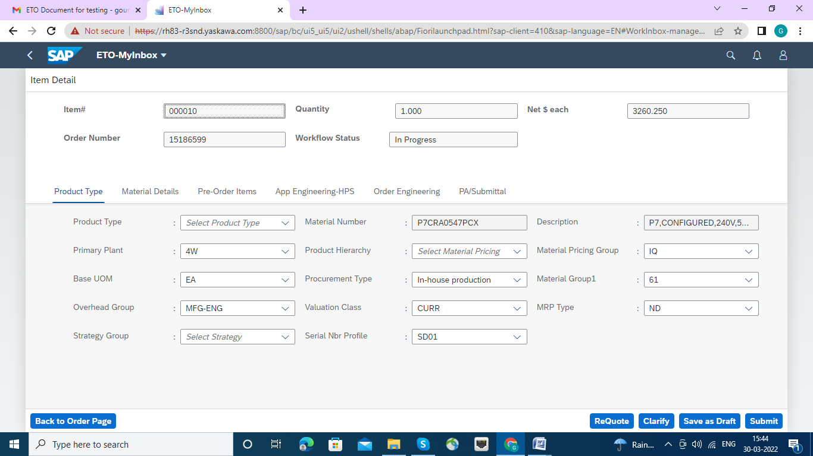

Below screen populated with Strategy Group.

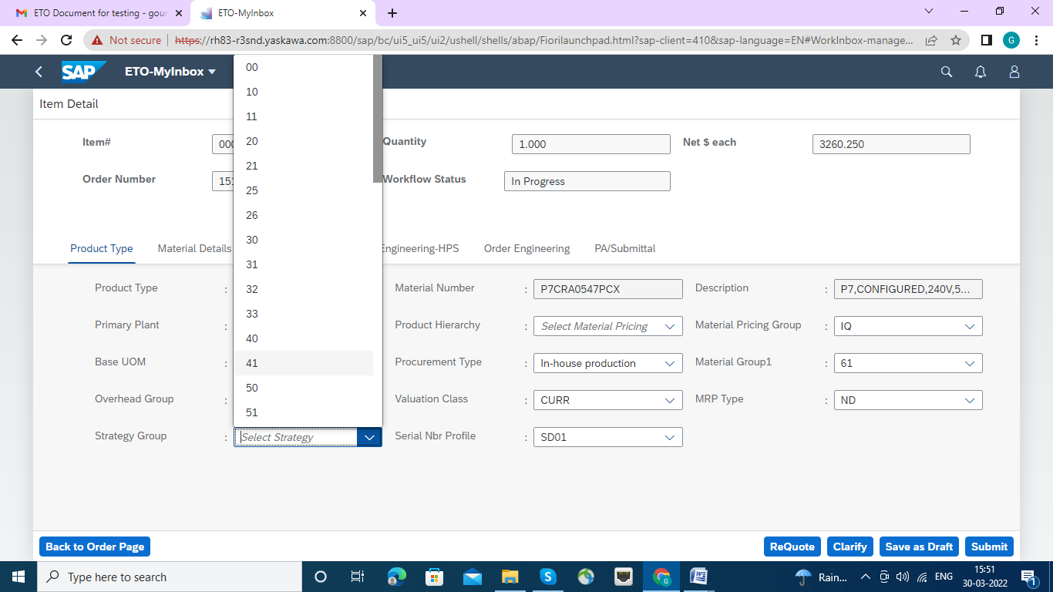

Strategy Group 20 selected.

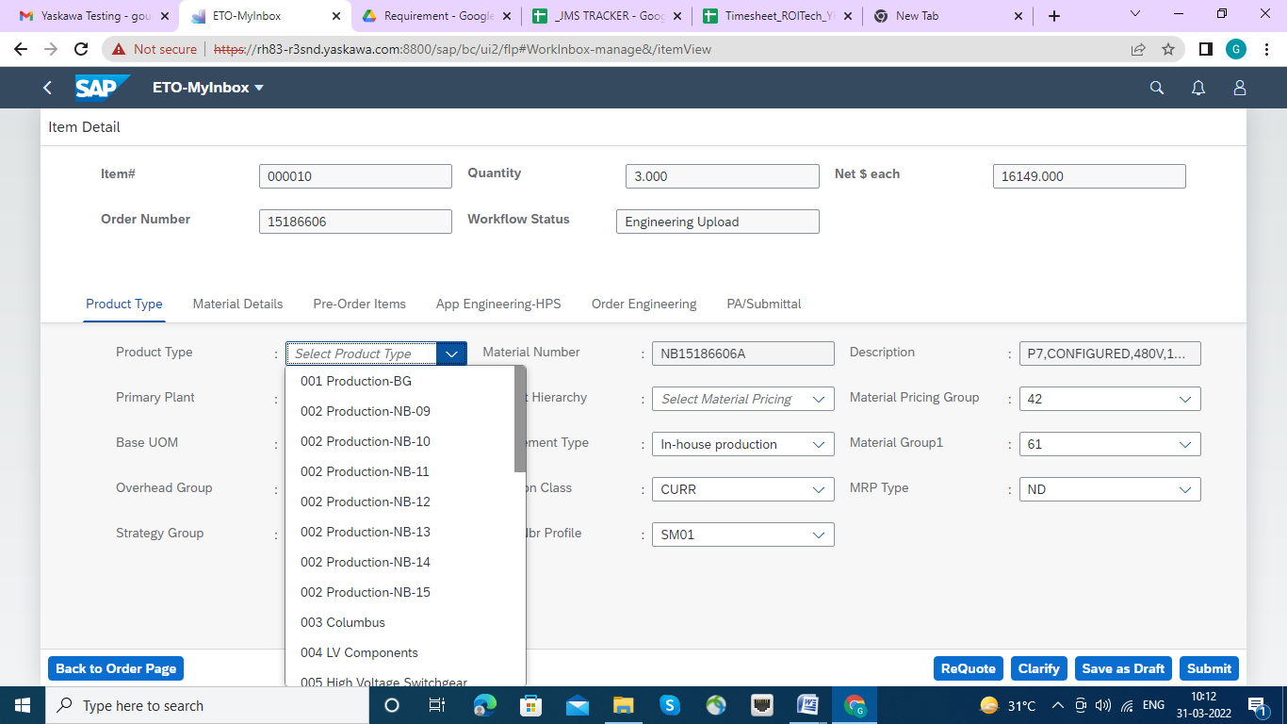

Product Type, Over Head Group, Material No. Product Hierarchy, Procurement Type Have also been selected from Drop Down list.

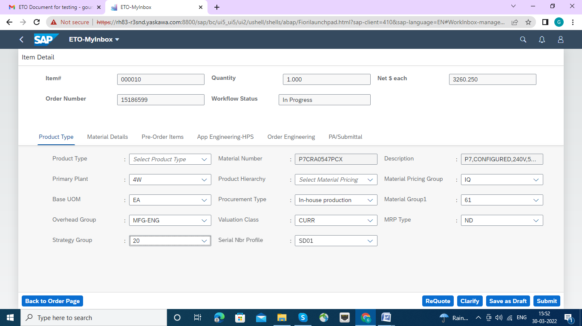

The Click on Submit Tab,

Warning Message has come , if want to proceed to complete click "OK" Button.

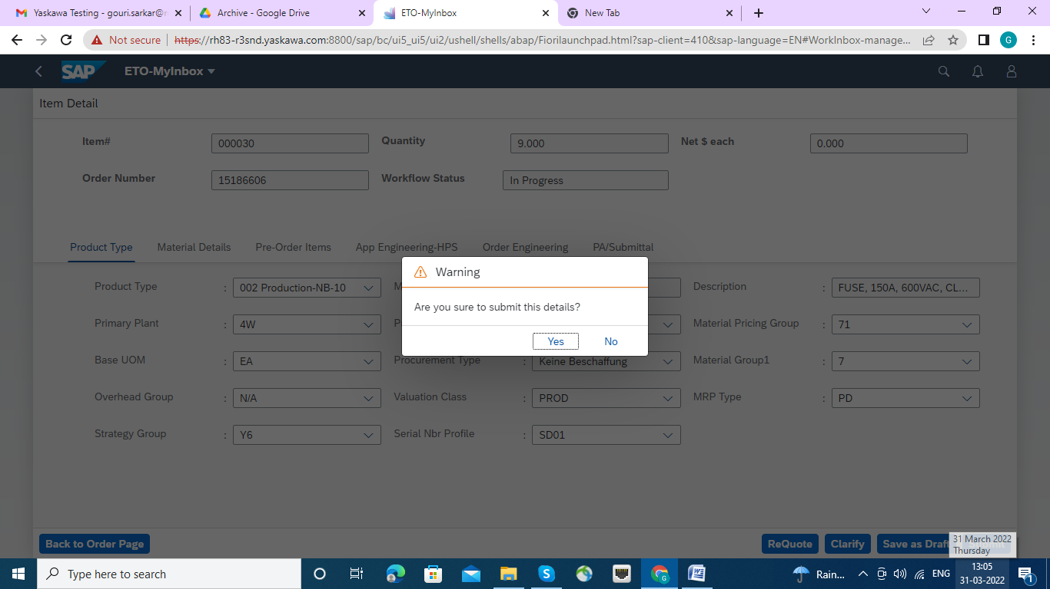

Now the Work Flow Status set to Engineering Scheduler. click ok button.

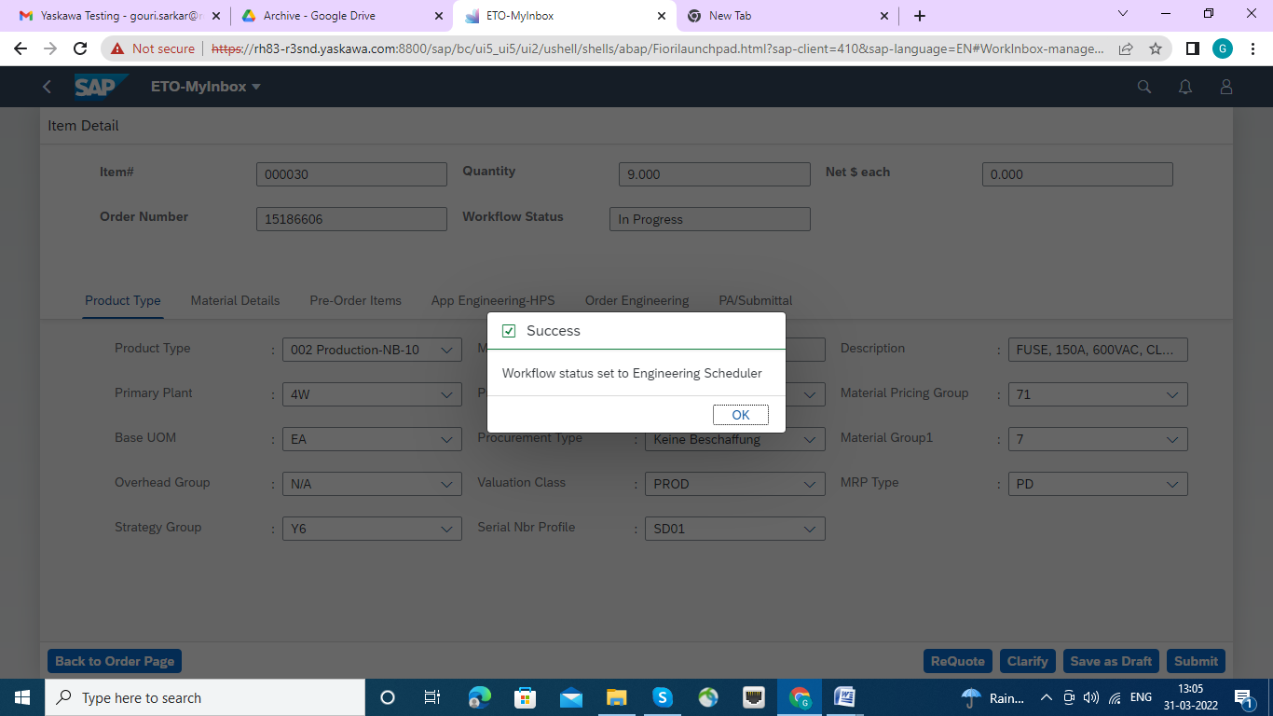

Now click on Material details Tab, Here Material Group , Production schedule profile and Requirement group have been populated from drop down screen which are mentioned in below to screens.

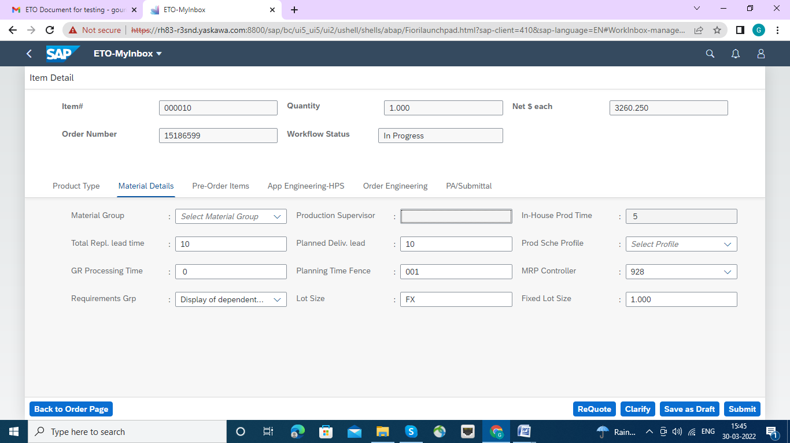

Material group is being populated.

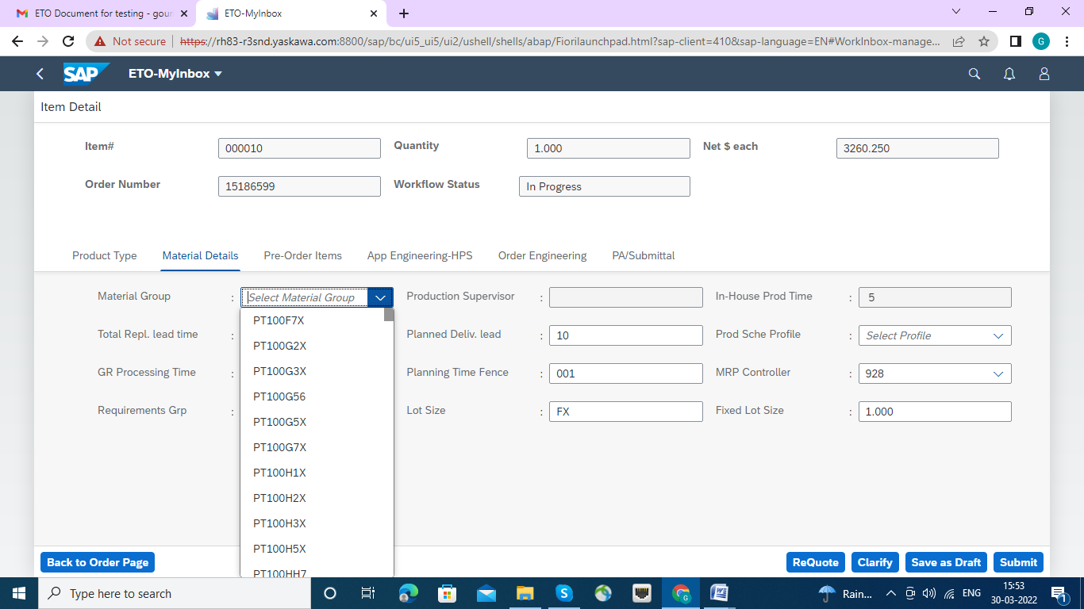

Requirement Group is being populated.

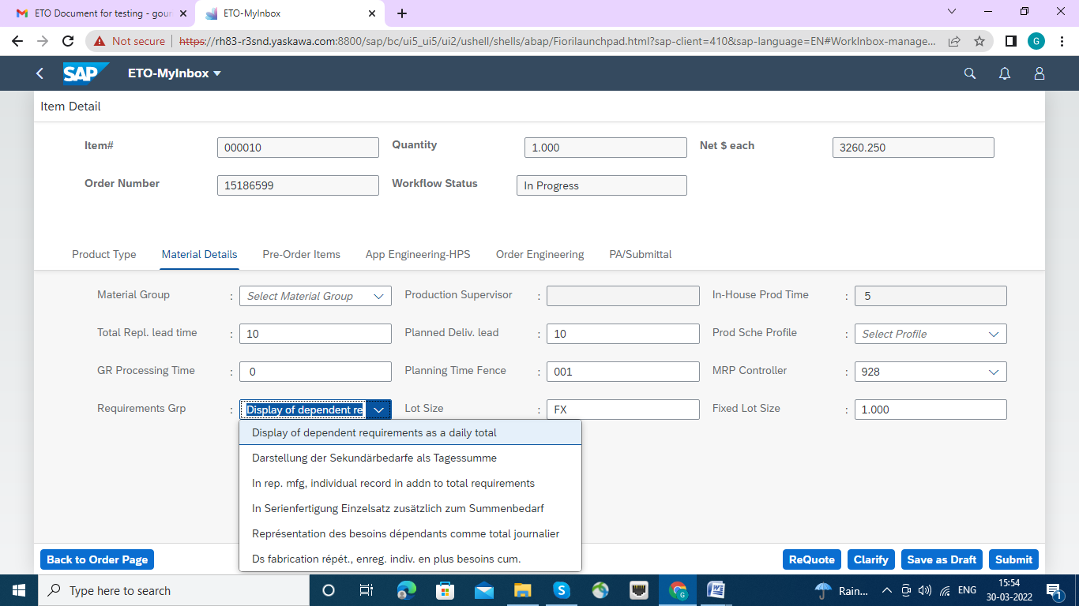

Production schedule profile has been populated.

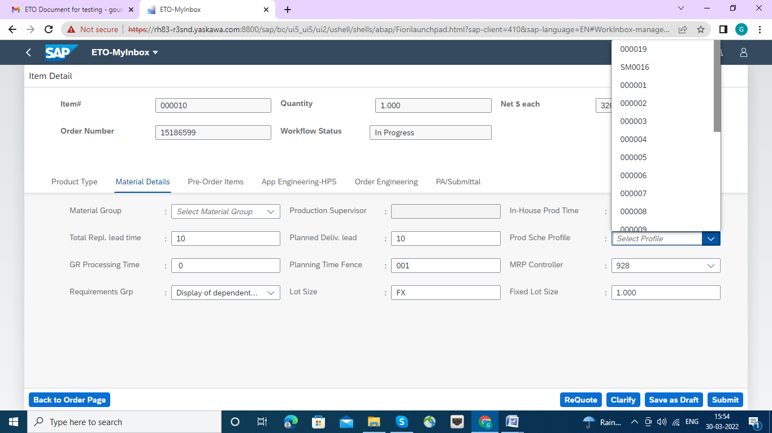

Nest Click on submit Button. This warning message will be appeared, Press Ok Button.

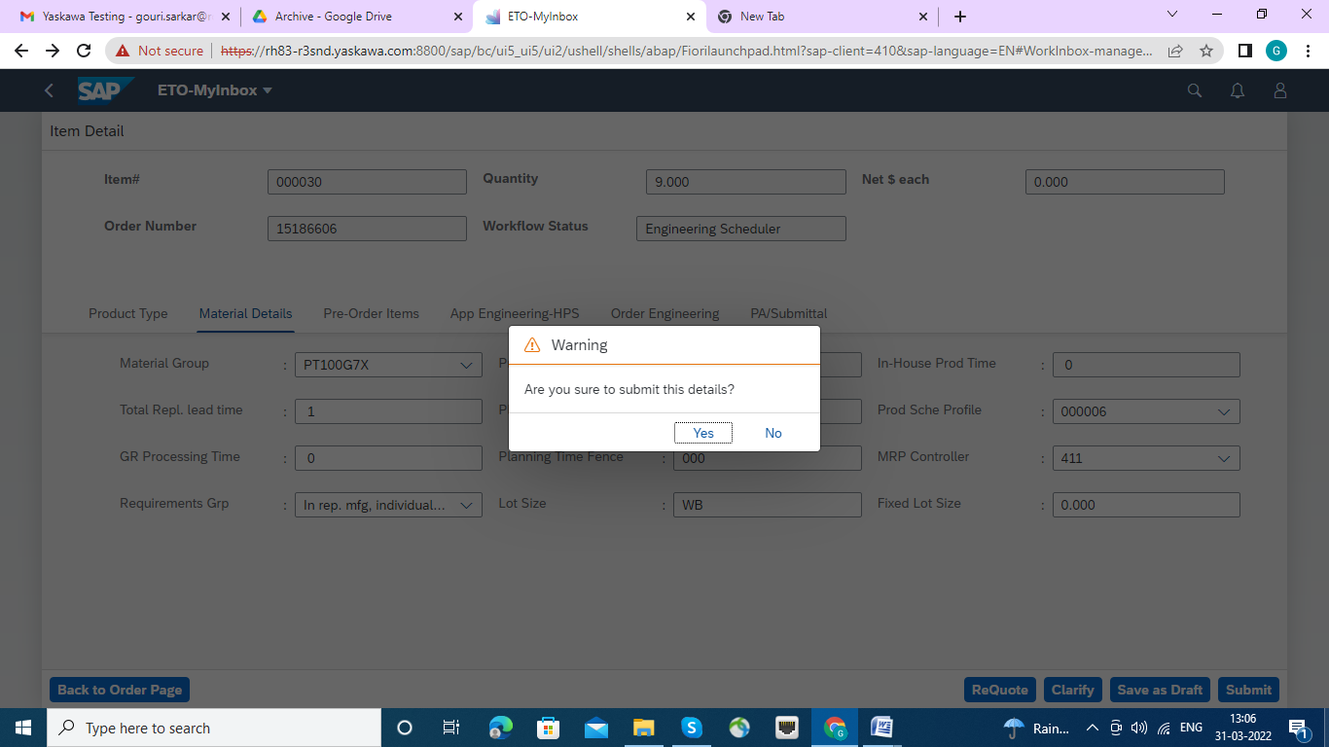

The Success Message will appear, Work flow set to Supply Planning HPS. click ok button

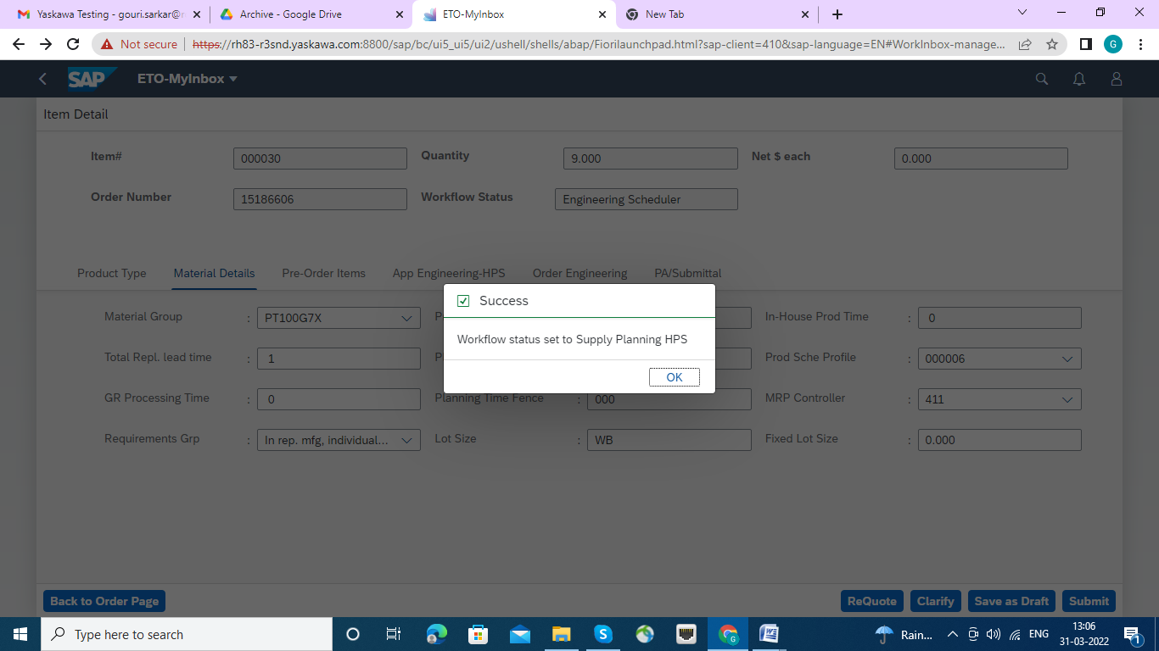

Neat Tab is Pre -Order Items, click on it., Any pre order item details can be added by following screen.

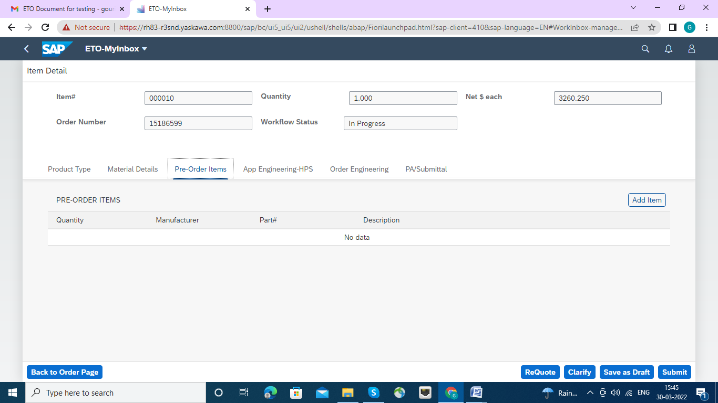

Adding Pre order Items below.

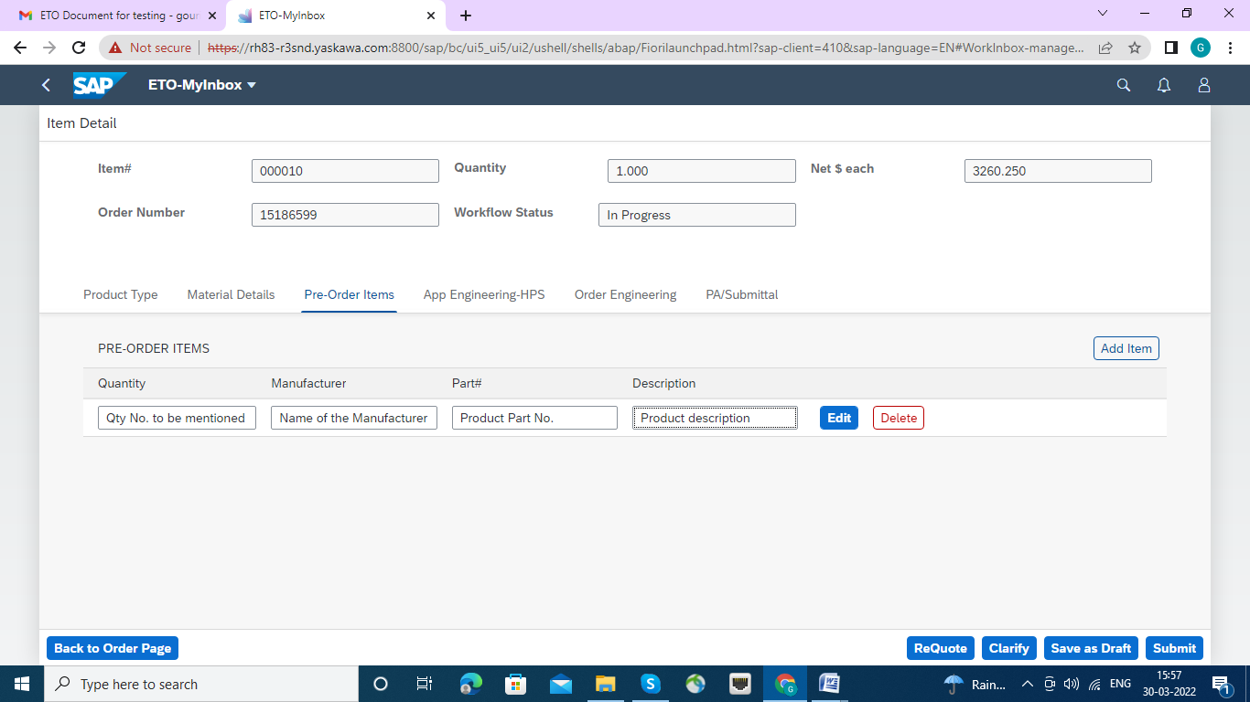

Now click submit button. accept yes button , though it is warning message.

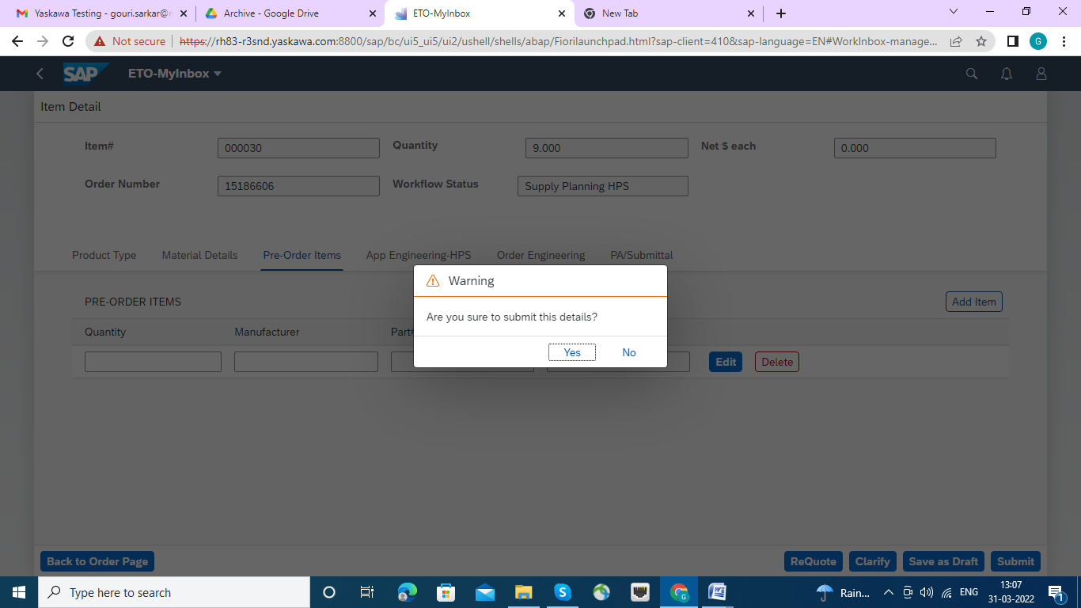

The success status set to Engineering upload. click ok button.

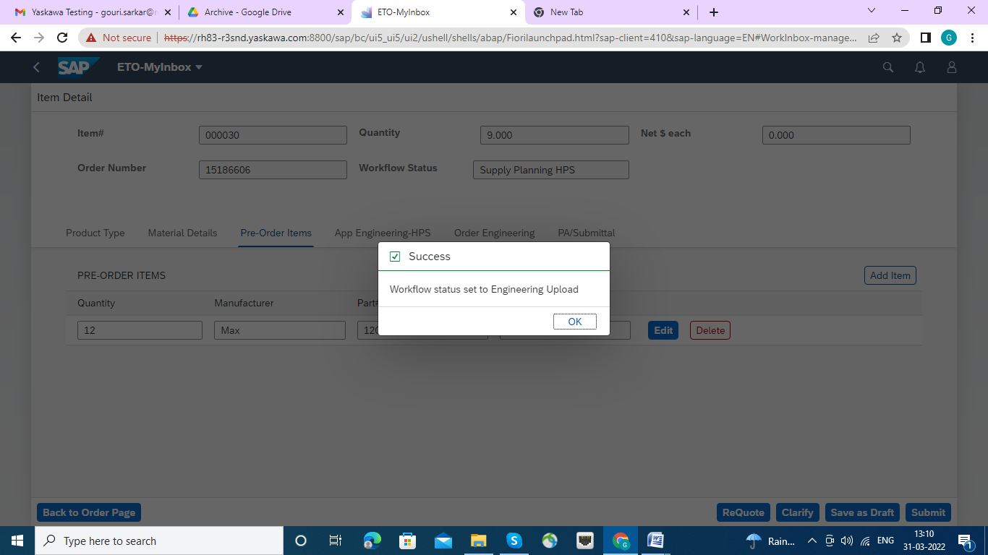

Neat tab is App- Engineering-HPS which is appeared blank,

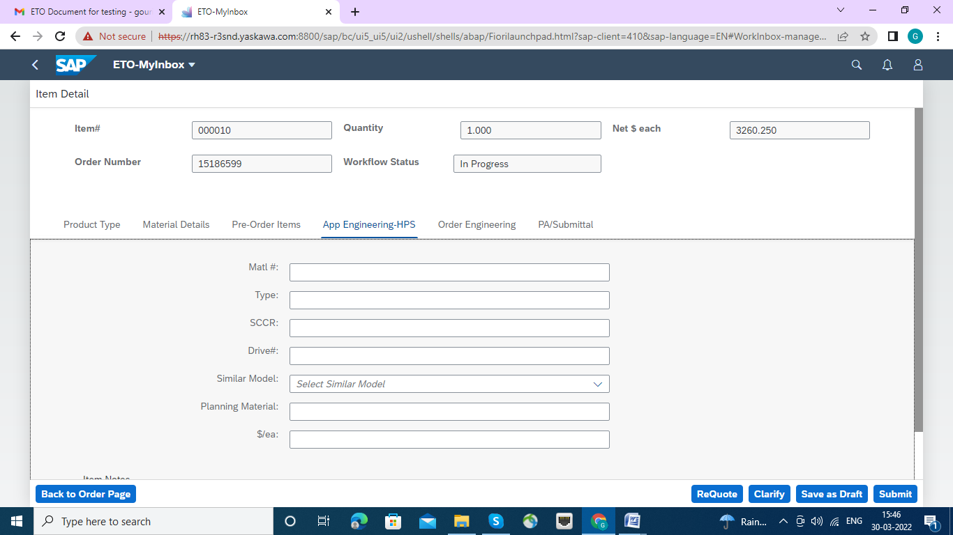

App Engineering HPS can be maintained with scheduled pre defined Narration.

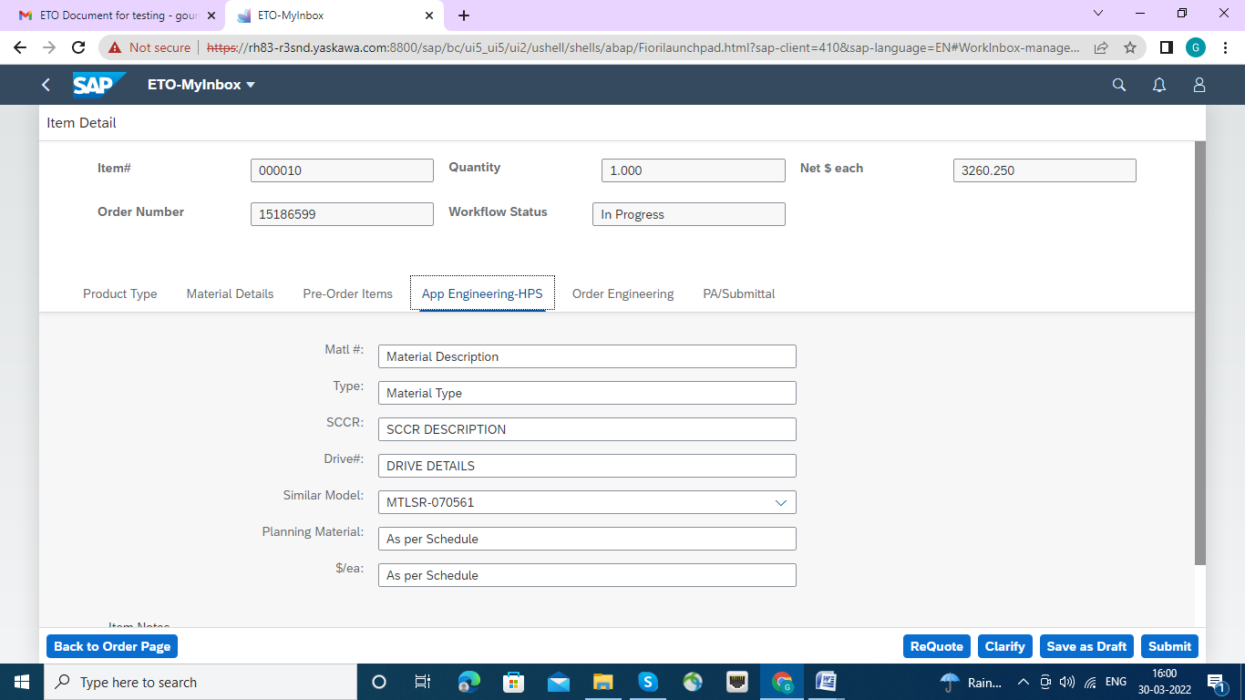

Next click on submit button and over look warning message and press yes button.

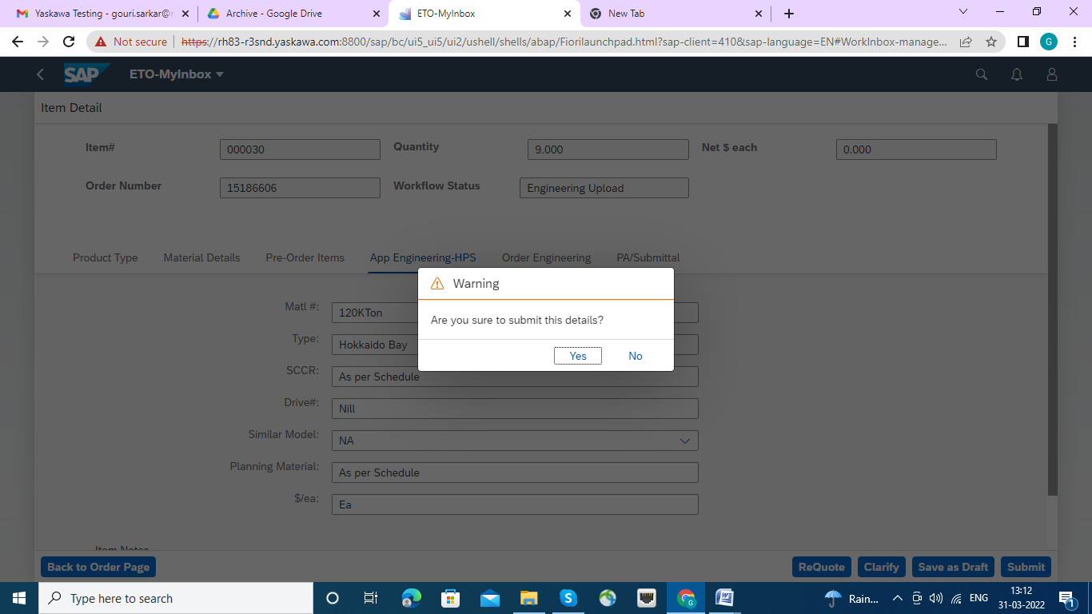

The success message will appear. Workflow status set to Order Engineer HPS.

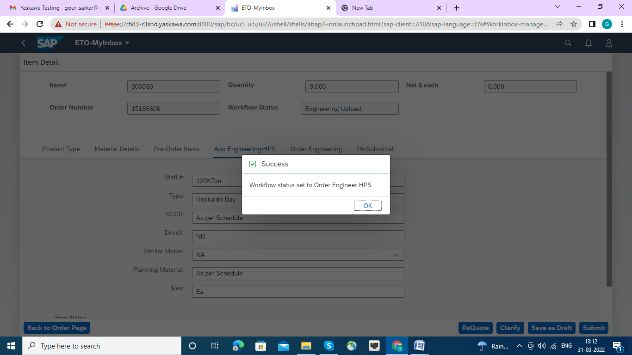

Click on tab Order Engineering, here also Text boxes and Check List appeared blanks.

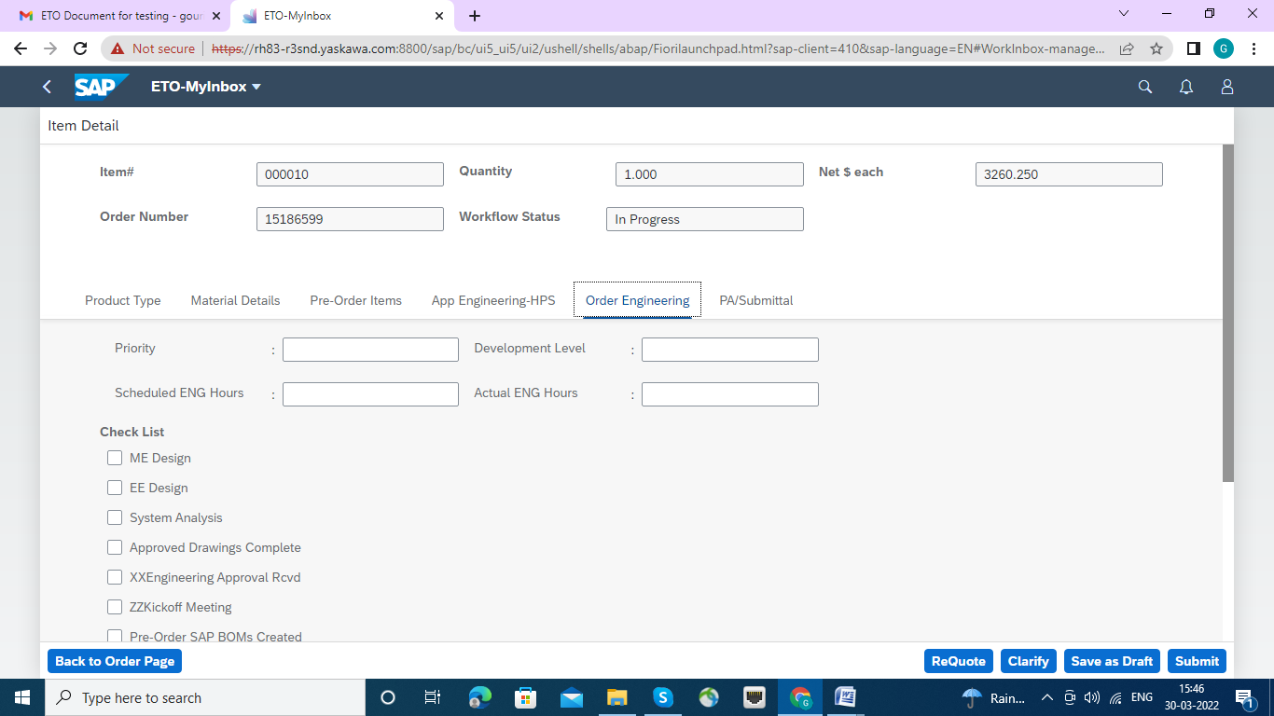

As per requirements and as per schedule pre defined guideline all check boxes and Text Boxes can be made up with.

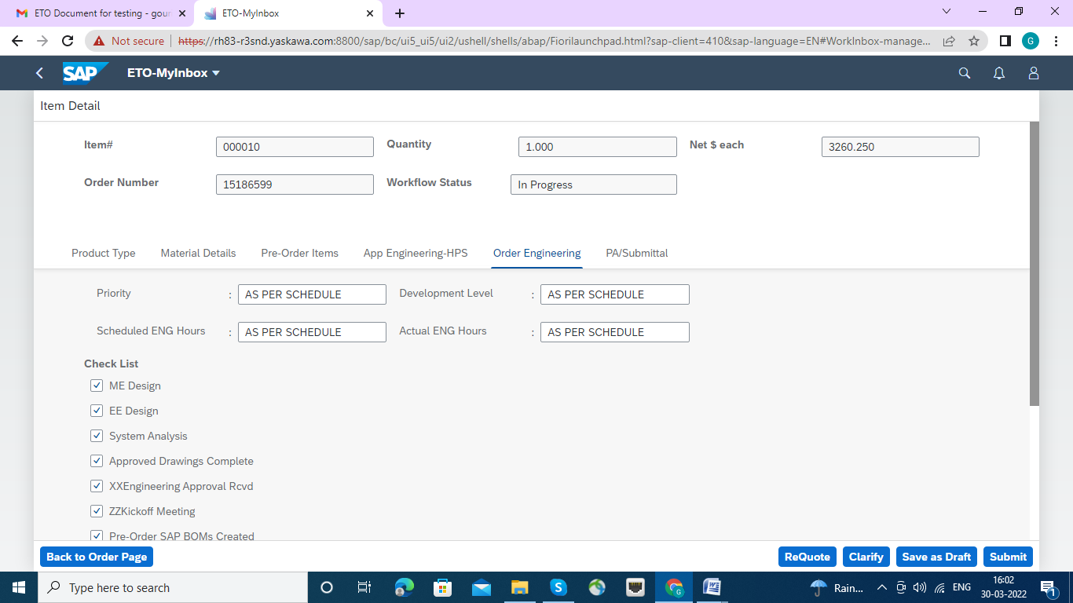

Click on submit button and overlook warning message.

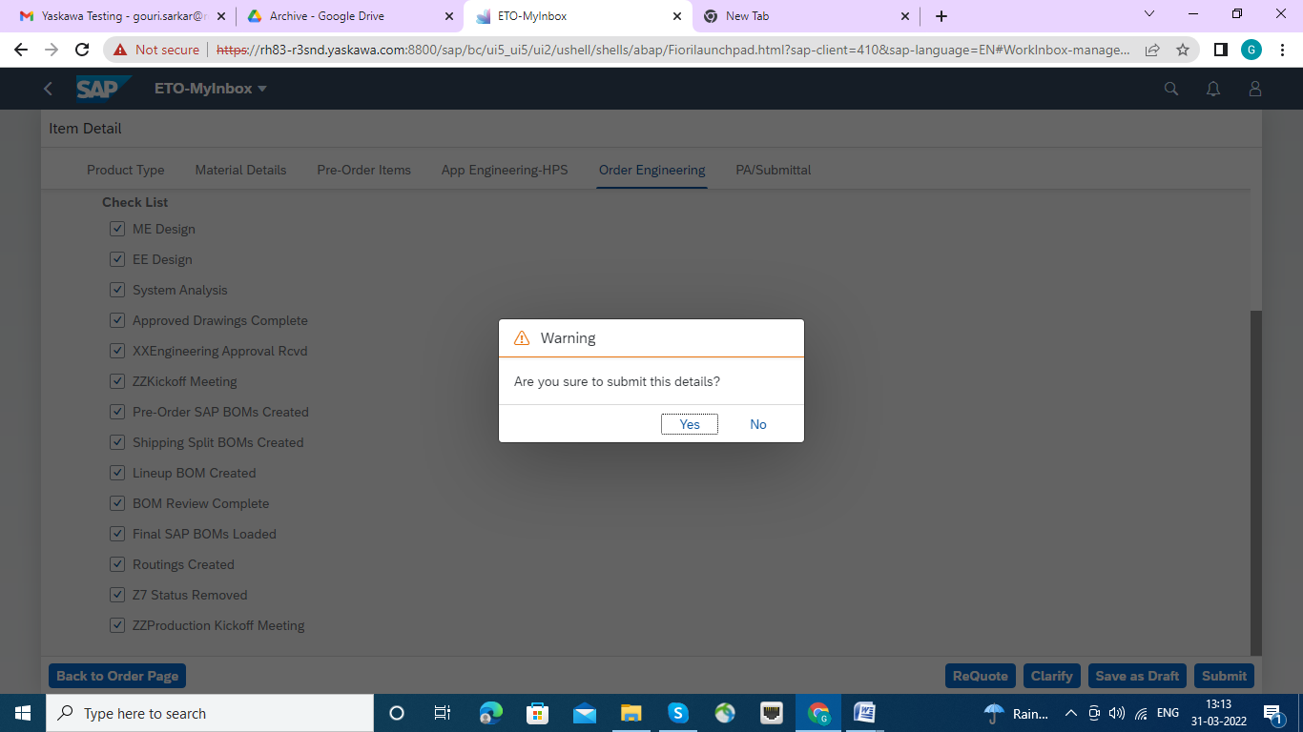

The success message will appear , workflow status set to Engineering Scheduler. click ok button.

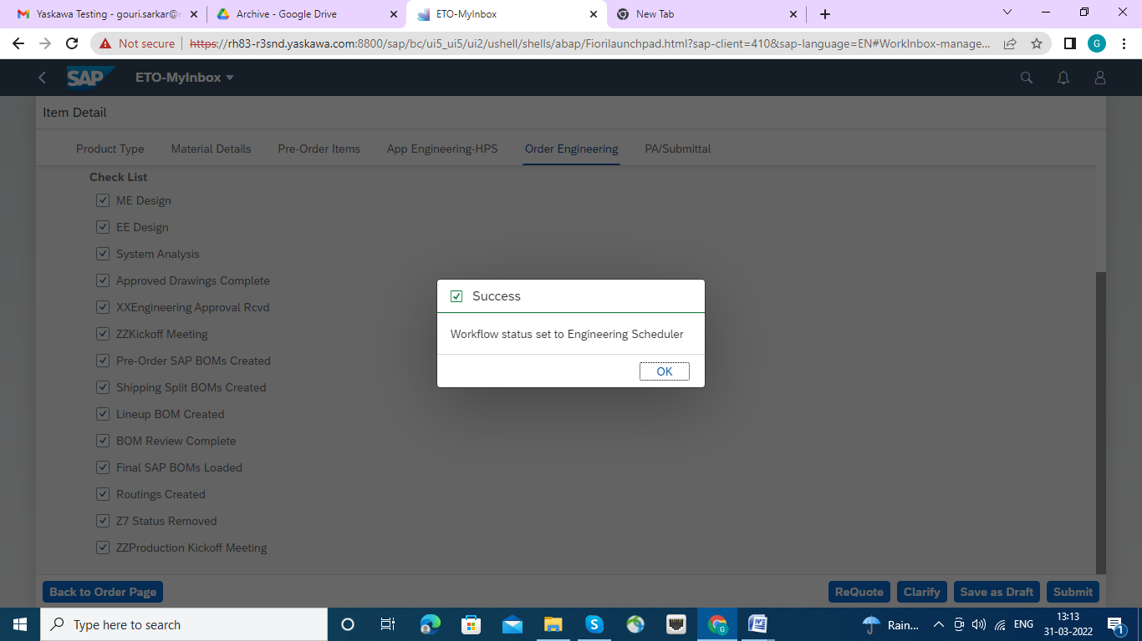

Click on Tab Tab is PA/Submittal ,

Since this is submittal page as per schedule pre defined guideline all check boxes and Text Boxes can be entered and validated.

Attachment or Attachments can be uploaded here by selecting "Add Attachment" Tab. And can be remove the attachment the delete tab which will be appeared once upload has been done.

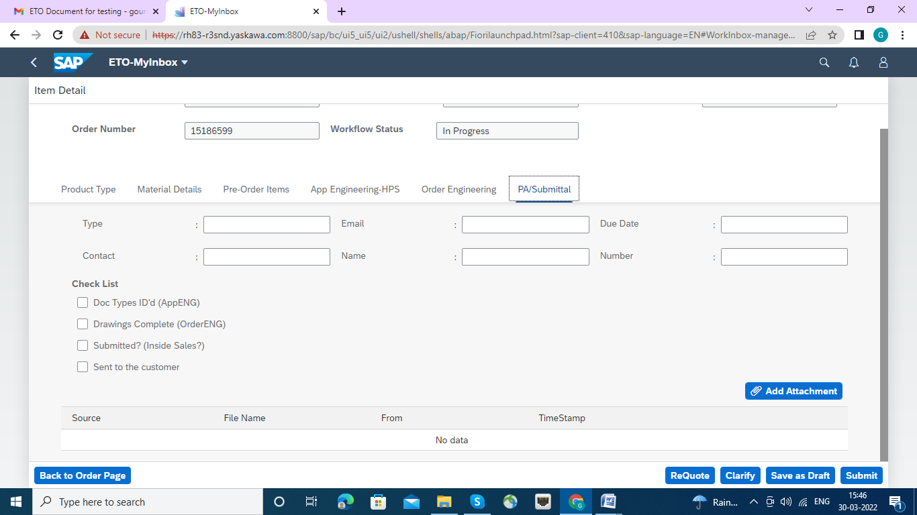

For an example some samples are populated in the below screen. Also and attachment is also uploaded.

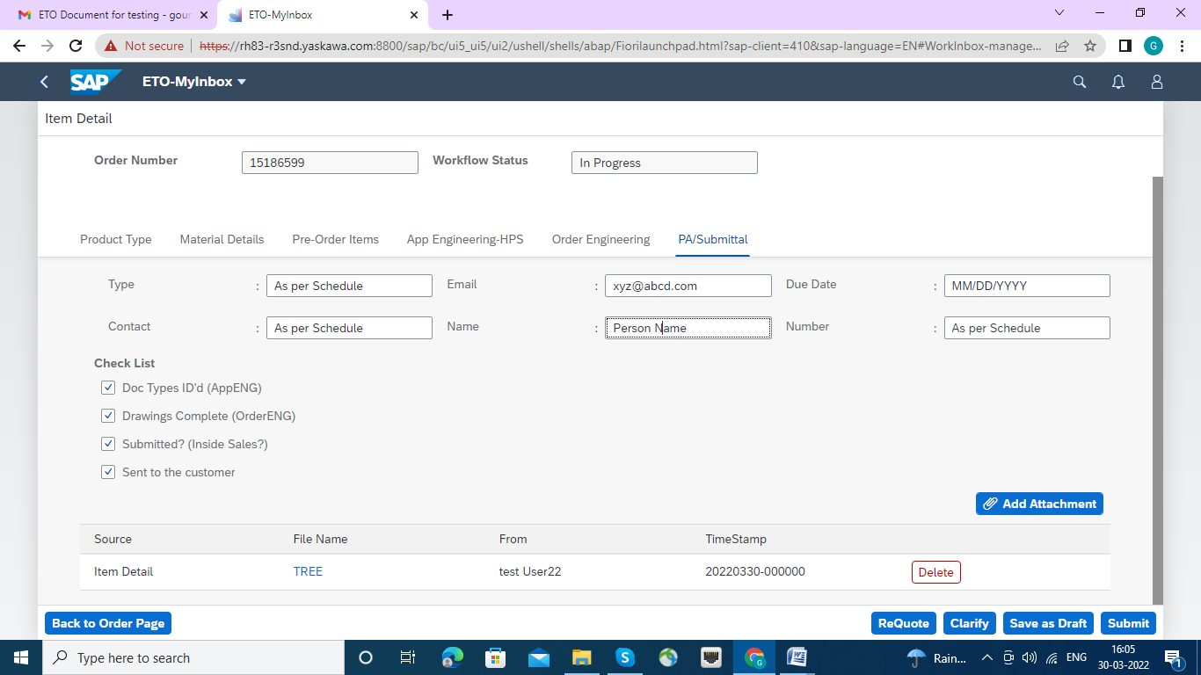

Click on submit button , and then on the “Yes” Button.

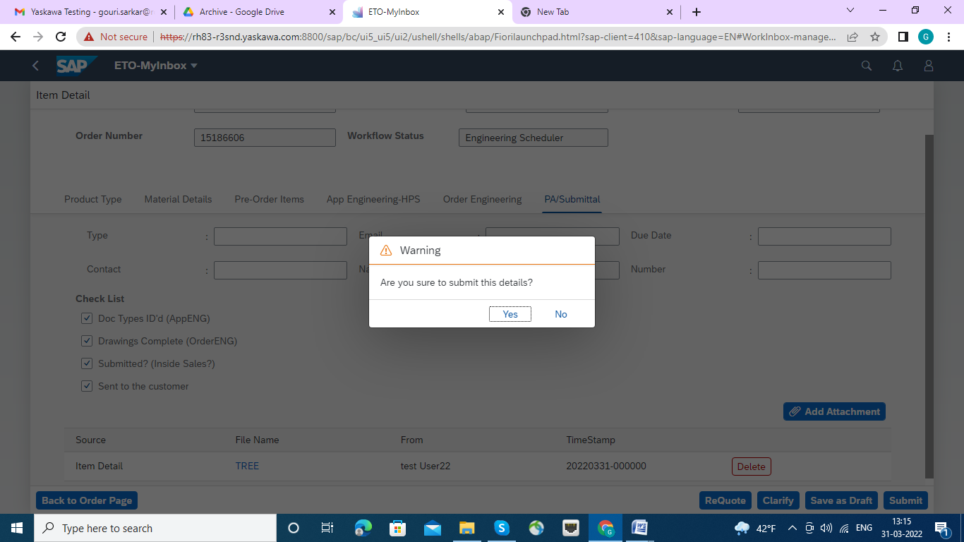

The following Message will appear , Workflow status set to MARCOM HPS. Click ok Button.

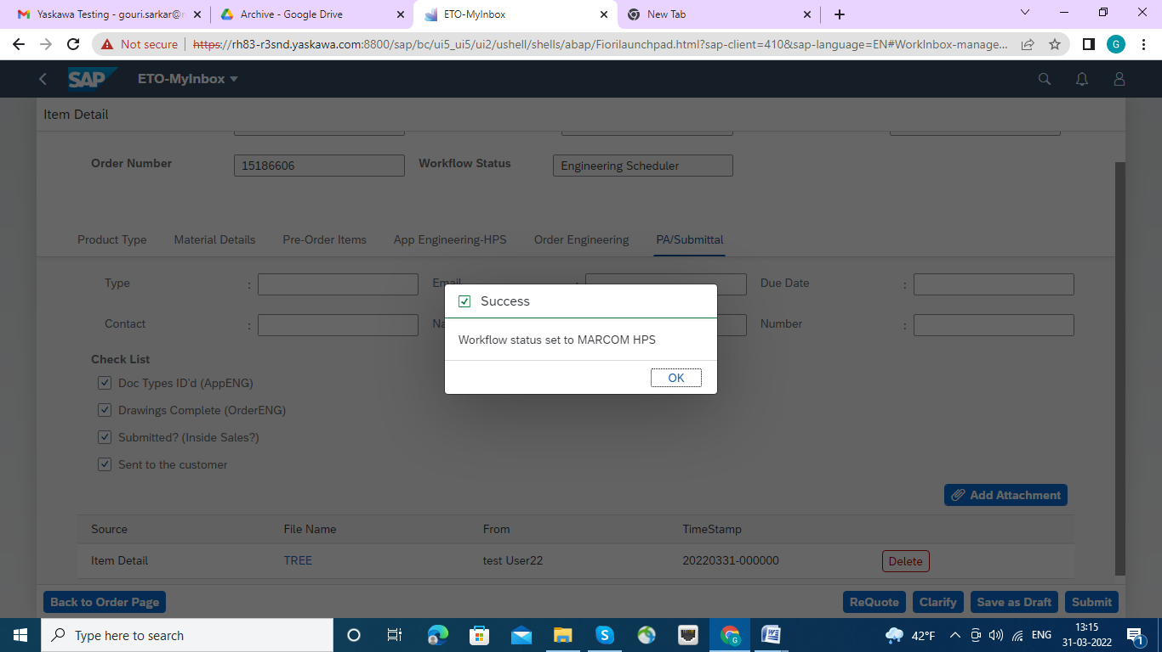

**Once again user will submit the button this time complete message generated in the work flow.**

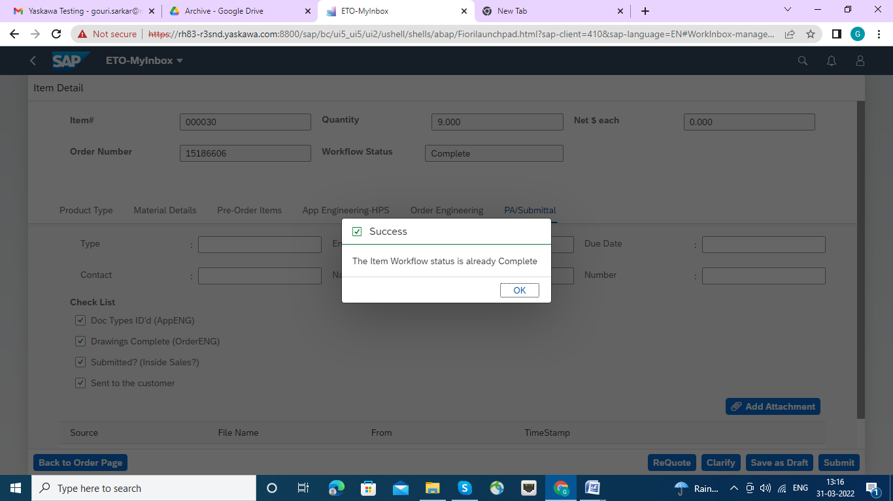

There are Three provisions.

1. **Re quote :** For Modification of Sales Order the Re quote button has to be pressed , Re quote will send mail to the inside sales person/Group HPS who then modify/do necessary action on it. And till Inside Sales person release the Sales Order , further process will be held.

2. Clarify : If line Item has to be modify and some one asked the clarify then the Clarify will send mail to the application engineer of the HPS group,who then modify/do necessary action on it. And till Inside application engineer of the HPS group release the Sales Order, further process will be held.

3. Save as Draft : any poit of thime can save as Draft.

1. Re quote: If it is necessary to Re quote , then press the Re quote Tab, a Text box will appear with Ok and cancel Button. Please input the Text as desired and submitted by OK button. If not required the press Cancel button.

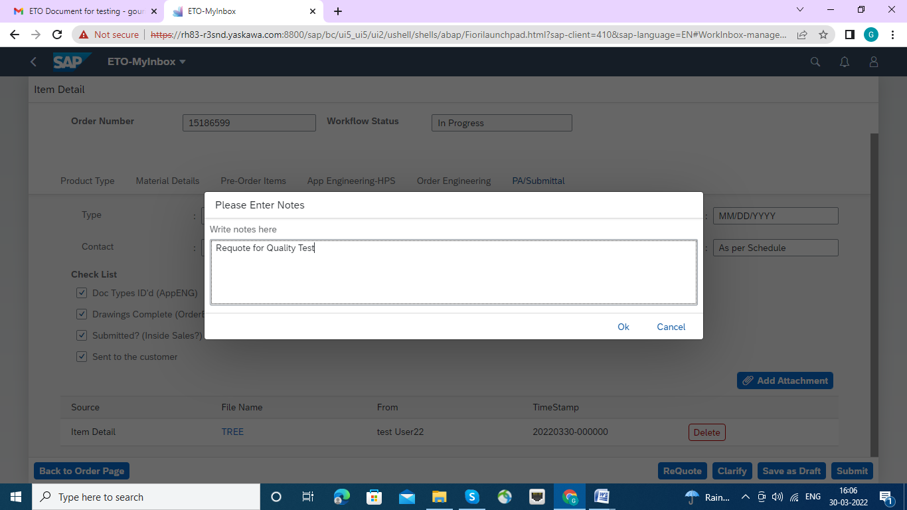

Once re quote successfully done the Success Message will appear.

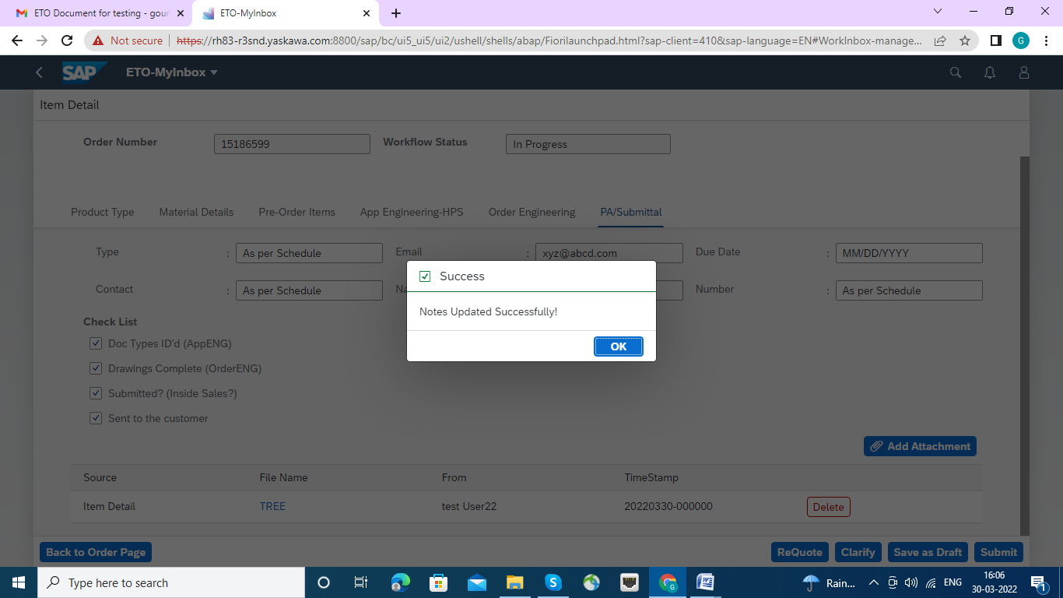

Then press the submit button, the workflow generated to Inside Sales.

2. Clarify: If it is necessary to Clarify , then press the Clarify Tab, a Text box will appear with Ok and cancel Button. Please input the Text to proceed as desired and submitted by OK button. If not required the press Cancel button.

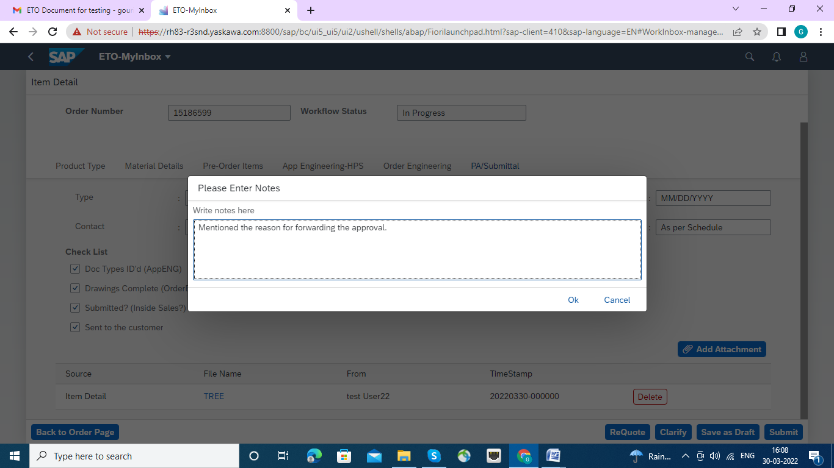

Once Clarify successfully done the Success Message will appear.

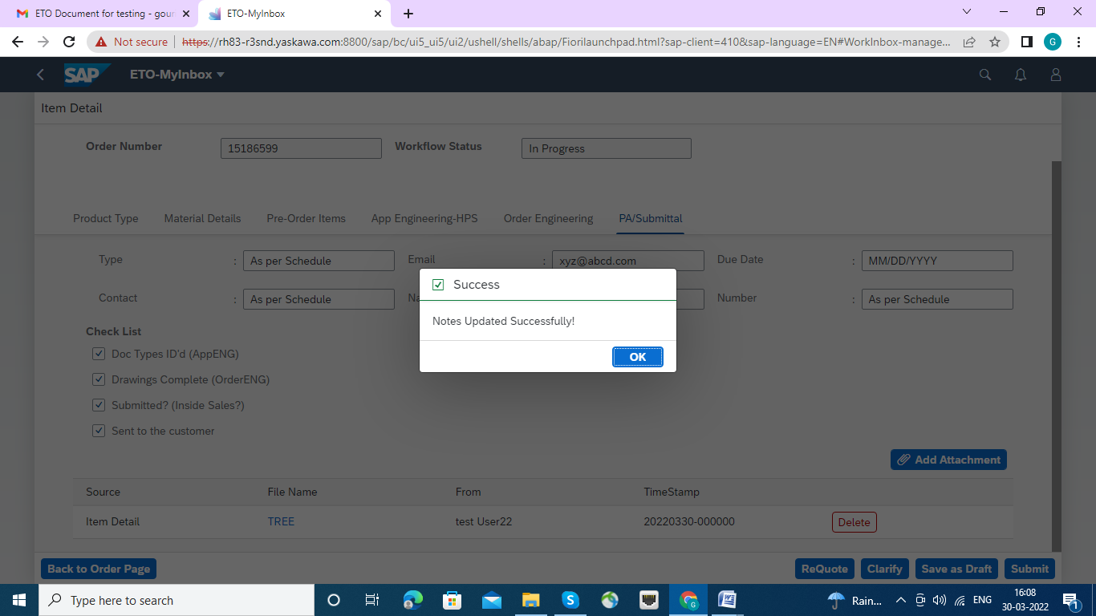

Then press the submit button, the workflow will be sent for clarification to the app engg group. Once the clarification is done it will be sent back to the requestor of the clarification

Save as Draft------- If it is necessary to Save as Draft , then press the Save as Draft, a Text box will appear with Ok and cancel Button. Please submitted by OK button. If not required the press Cancel button.

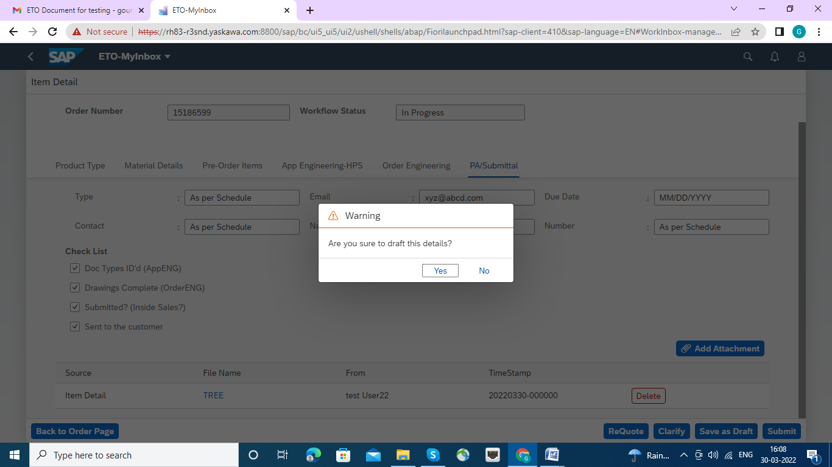

Once OK button clicked the Success Message will appear so that it is saved as Draft.

